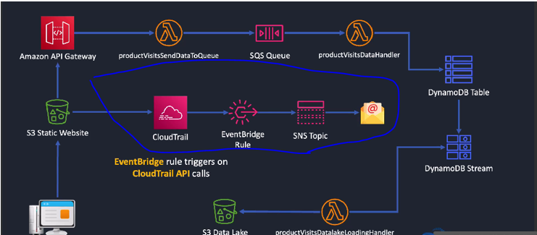

Note that the CloudTrail is not specific to the static website S3 bucket but for all resources in your account / organization. Our implementation in this project only tracks S3 bucket level API calls via cloudtrail.